Resources for identifying patients who have opted out of genetic/tissue research

General Information
The primary purpose of this document is to provide information about where to find opt-out information. More information about the Oregon Genetic Privacy Law and opt-out requirements can be found in the Oregon Genetic Privacy Law and Genetic & Tissue Opt Out at OHSU training course.

Briefly, all OHSU patients are given the opportunity to decline to have their biological samples stored and used for future research and/or to have their health information or biological samples used for anonymous or coded genetic research. Opt-out information is collected in the electronic medical record (EMR) system, and can be used to exclude patients from research studies involving genetic/tissue research.

For more information about conducting genetic research, please see the following:
http://www.ohsu.edu/xd/research/about/integrity/irb/genetic.cfm
For more information about Oregon Genetic Privacy Laws, please see the following:
https://www.ohsu.edu/information-technology/oregon-genetic-privacy-laws
For the most current Notice of Right to Decline, please see the following:
https://www.ohsu.edu/sites/default/files/2022-12/OHSU_Notice_Right_to_Decline_Future_Sample_Research.pdf

When patients need to be identified/excluded
- For special considerations for anonymous and coded genetic research, or to determine if your study qualifies as genetic research, please see the following: http://www.ohsu.edu/xd/research/about/integrity/irb/genetic.cfm.

- If the exact use of health information and/or biological samples in genetic/tissue research has been specified via a consent process, that consent will supersede opt-out status. If genetic/tissue research is being conducted in a way not specified via consent, opt-out status for any study participants must be verified, and patients who have opted out must be excluded.

- All studies involving tissue/genetic components should have identifying information in the eIRB.
- There will be language in the protocol indicating that tissue/genetic samples will be used
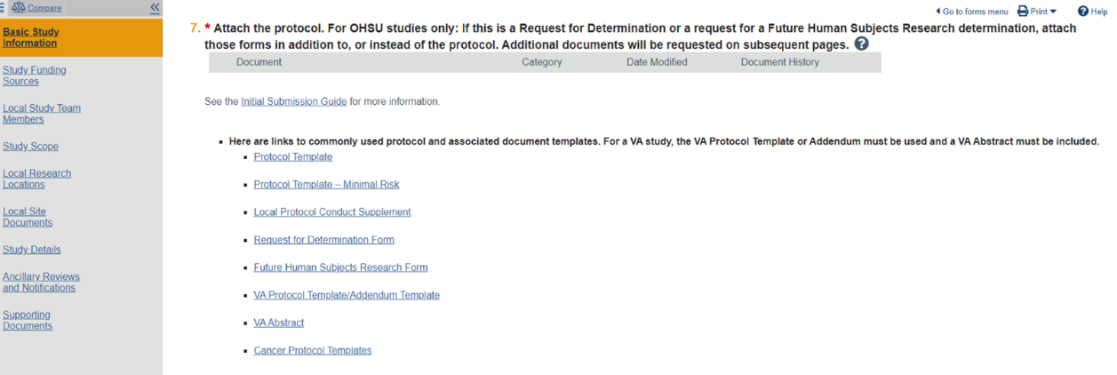
- The consent form, Waiver of Authorization, local protocol conduct supplement and the data security supplement for waived studies all have genetic questions on them.
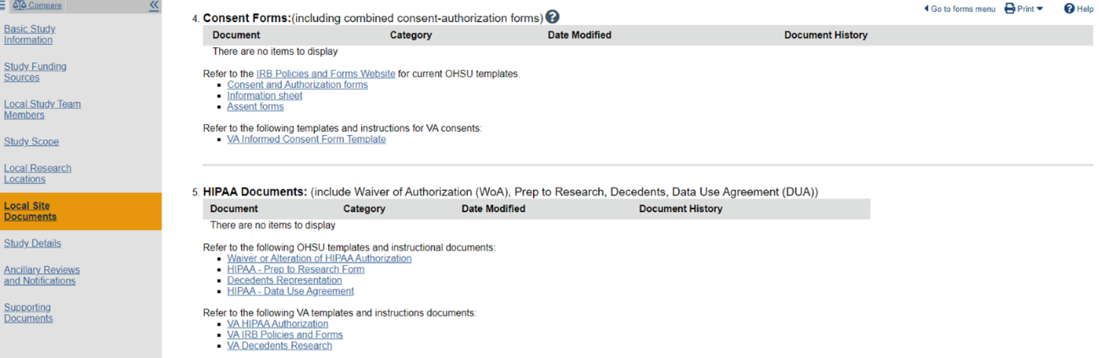

- Under Study Details- Repository may be checked (not in all cases)
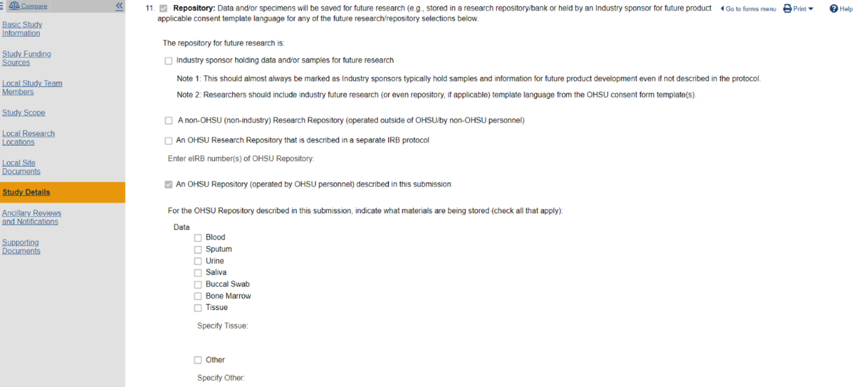

- Please note that research at OHSU Health Affiliates is restricted, and requires special permission (https://o2.ohsu.edu/research-affiliate-sites). If you are attempting to find opt-out status for patients from an affiliate site, it is assumed you have received permission to conduct research with that affiliate.

Identifying patients
- For those working with the Clinical Research Informatics (CRI) Research Data Warehouse (RDW) team or those who are members of that team: The RDW houses information that identifies these patients.

- For those working with the Business Intelligence and Advanced Analytics (BIAA) teams/Information Technology Group (ITG) or who are members of those teams: The same information that is housed in the RDW to identify patients that have opted out is also brought into the Caboodle Data Warehouse (CDW) where analysts with access can find the information.

- For those who are searching for samples via the Knight BioLibrary, RDW information on opt-out status is available by direct request.

- For those who have identified a list of samples of interest using Case Finder (Business Objects – WEBI), opt-out information has been integrated into that tool. The opt-out information is brought in from the CDW (see second item).

- For all others who have a list of patients, from which they would like to exclude patients who have opted out, the OCTRI Genetic Opt-Out tool can be used. Access requires a Computer Access Request System (CARS) request for “OCTRI_Genetic_Opt_Out_Portal”. Detailed access instructions can be found in the Oregon Genetic Privacy Law and Genetic & Tissue Opt Out at OHSU training course.
  - For RDW opt out logic or for information about the OCTRI Genetic Opt-Out tool, please visit the Help page here: https://octriinternal.ohsu.edu/optout/help

