NIH Data Management and Sharing Policy – QuickGuide

General Guidance
For questions about the DMS policy or formulating a data management and sharing plan, most people should start with the library. The library team has a guide that focuses specifically on the DMSP policy. They also have office hours dedicated specifically to Data Management questions, both on-campus and online.
The library can help with questions about what to include in your data management and sharing plan, what data to share and where to share.
There is also a tool that can be used to help generate a draft of your plan (DMPtool.org) that includes OHSU library guidance. If you have not worked with DMPtool.org before, you will be asked to create a new account. Be sure to select Oregon Health & Science University (ohsu.edu) as your institution in order to see OHSU guidance. Once you have created an account, when you log in you will be given an option to sign in with your institution via SSO.
The Office of the CRIO can also help with questions about how to share data (e.g. regulations and compliance, options and processes for storing and sharing data) if needed. Please contact researchdata@ohsu.edu.

Note on studies involving data from human subjects
There are specific risks and privacy concerns when working with data from human subjects
- Even de-identified data has some risk of re-identification, so controlling its release with a data use agreement is recommended.
- Some data does not allow release: secondary use of data, such as data extracted from an EHR with a waiver of consent or claims data obtained through contract, have restrictions on release that the investigator cannot change.
- Standard consent forms may not contain language about sharing: this means the release of data is not allowed beyond the specific uses described in the forms.

Examples of ways to still share and address these risks:
- Anonymization of data is possible: if all PHI is removed AND determination of statistical risk of reidentification is so low as to be practically impossible, then this could allow broader release. However, most investigators cannot do this alone. Synthetic data creation using your source data as a start could be an option. While OHSU does not currently have a contract with a synthetic data vendor, you may be able to speak with a statistician or biostatistics group (like the BDP or KCI Biostatistics).
- External repositories that accept de-identified patient level data are aware of privacy concerns, and can guide you as to the steps. Do this before submission of the proposal – or, at the latest, before you create your IRB submission.
- A key step is to use a consent form with description of the sharing that is included. You can find suggestions via the Knight Cancer Institute consent templates, or via the OHSU Research Integrity consent templates (specifically the “Consent and Authorization Forms – Clinical (12.13.2018)”, page 11 of 17).
- Finally, you can work with OHSU approved steps to establish a repository.
  - You need to check the box in the IRB that notes this is a ‘data repository’.
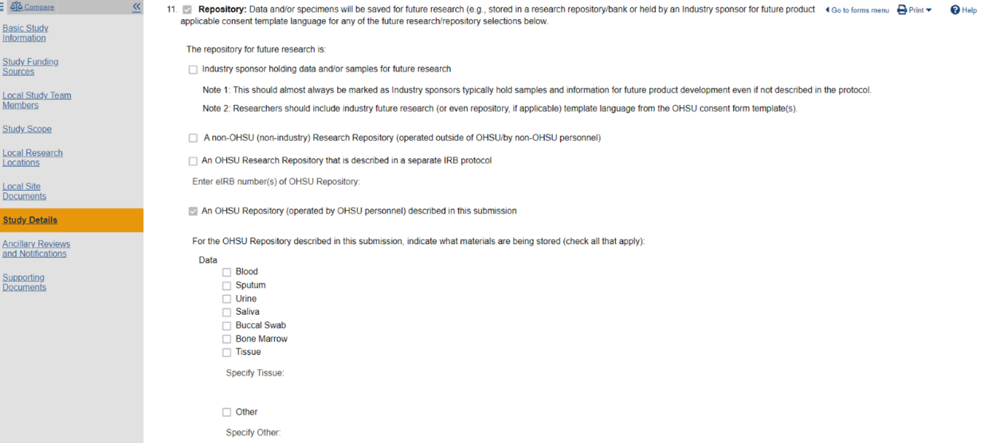
  - You will need to either identify an existing, active, IRB-approved repository, or you can start a new repository. To start a new repository, a repository-specific IRB protocol will need to be submitted. There are also a series of documents you need to include in your IRB submission: Repository Forms
  - In the future, you may also be able to work with OCTRI Informatics to establish a repository.

FAQ*
*Note that much of this information is taken directly from the NIH sites (https://sharing.nih.gov/), the DMS_Webinar_Resource_Slides that can be found at https://sharing.nih.gov/about/learning, and the data sharing FAQ (https://sharing.nih.gov/faq). More details can be found by exploring those resources.
Jump to:
When did the policy go into effect?
Do I need to share my data?
What data do I need to share?
What options do I have for sharing?
What options do I have for oversight?
When should data be shared?
For how long should data be shared?
Are there any restrictions on what can be included?
Budgeting
Resources

When did the policy go into effect?
The policy went into effect January 25 ,2023

Do I need to share my data?
The DMSP applies to all research, funded or conducted in whole or in part by NIH, that results in the generation of “scientific data”.
- Scientific data is defined as “the recorded factual material commonly accepted in the scientific community as of sufficient quality to validate and replicate research findings, regardless of whether the data are used to support scholarly publications.”
- Including but not limited to:
  - Research projects
  - Certain Career Development Awards (Ks)
  - Small Business SBIR/STTR
  - Research Centers
- Does not apply to:
  - Training (Ts)
  - Fellowships (Fs)
  - Certain non-research Career Awards (e.g. KM1)
  - Construction (C06)
  - Conference Grants (R13)
  - Resources (Gs)
  - Research-Related Infrastructure Programs (e.g. S06)

What data do I need to share?
You do not need to share laboratory notebooks, preliminary analyses, completed case report forms, drafts of scientific papers, plans for future research, peer review communication with colleagues or physical objects (e.g. laboratory specimens).
You do not need to share data that are already available elsewhere (e.g. Epic data). However, secondary data that is generated may be subject to sharing (within limitations of repositories and OHSU policies).
Raw data may not need to be shared. For studies involving data from human subjects, there are strict limitations on the sharing of PHI. For all studies, data only needs to be shared if it is necessary or of sufficient quality to validate and replicate the research findings. Secondary or Processed/Analytic data may be alternatives. There may also be options for storing data at OHSU and sharing metadata publicly.
Recognized limitations on Sharing:
- Informed consent will not permit or limits scope of sharing or use
- Privacy or safety of research participants would be compromised and available protections insufficient
- Explicit federal, state, local or Tribal law, regulation, or policy prohibits disclosure
- Restrictions imposed by existing or anticipated agreements with other parties

What options do I have for sharing?
Established repositories are encouraged, but not required. Note that NIH Institutes may designate specific data repositories.
Special note for all research studies except those qualifying as non-human subjects research, guidelines for research repositories must be followed. Repositories require a protocol, sharing agreement, submittal agreement and tracking form. Additionally, all non-EPIC repositories storing PHI must be entered into the OHSU Health Information Registry, see: https://www.ohsu.edu/information-technology/resources. Per the OHSU guidelines:
- “The collection and storage of specimens/data becomes a research repository when there is a specific intention for the data/specimens to be used repeatedly for research purposes, or stored for future research or shared with other investigators.”

OHSU Resources for storing data
  - Metadata
    - OHSU Data Catalog
  - Internal storage/Internal study-specific repositories (raw and analytic datasets)
    - Investigators are encouraged but not required to submit data to an external repository. It is possible for investigators to store data as they normally would (e.g. X Drive, via ACC, etc.) IF they make metadata (information about the data and how to access it) publicly available. Please see note above for all research involving data from human subjects.
    - In the future, there may also be an option to create a repository with OCTRI Informatics
    - Investigators will be able to search the OHSU Data Catalog for existing internal specialist repositories
  - Internal Generalist Repositories
    - There are no OHSU-wide generalist data repositories at this time, though that may change in the future.
External Repositories
- Selecting a Data Repository
- PubMed Central supplementary material
- NIH Institute specific repositories
- Generalist repositories
- Nature’s Data Repository Guidance
- Registry of Research Data Repositories

What options do I have for oversight?
There is some flexibility in the roles of those responsible for oversight. These are the key elements:
- Who is responsible for submitting information to a repository and/or collection, analysis storage and sharing, data quality (e.g. a study team member role such as data manager, study coordinator, research assistant)
- Who will ensure data are shared according to the DSMP and how - e.g. a specific team member responsible for reviewing the DSMP elements each time the data are shared
- Who will be responsible for monitoring compliance with the plan (most likely the PI) and how – Examples of this might be periodically reviewing which data were submitted to a repository and when, reviewing which data were shared and when, reviewing access information/metadata to ensure data are accessible as written
- Frequency – how often will compliance with the plan be monitored
- Where applicable try to include roles (e.g. a study team member or a Research Coordinator on the team) versus specific names (e.g. Jane Doe)

When should data be shared?
No later than the time of a publication of findings in a peer-reviewed journal OR at the end of the award, whichever comes first

For how long should data be shared?
There is no one size fits all option for this. Appropriate time frames vary across disciplines, and may depend upon relevant requirements and expectations:
- Data repository policies
- Award record retention requirements
- Journal policies

Are there any restrictions on what can be included?
There is a 2-page limit (although this can be negotiated if more space is needed)
You should not include hyperlinks
Do not include confidential, proprietary, sensitive information or PHI
Where applicable try to include roles (e.g. a study team member or a Research Coordinator on the team) versus specific names (e.g. Jane Doe)
Teams are encouraged to consult with the program officer for the funding institute and/or institute-specific guidelines

Budgeting
Costs for the DMSP sharing plan will vary depending on your need. The Library NIH Policy Guide has a whole section on budgeting and allowable costs. We will also be working to include some examples of accepted budgets as they become available.

Resources
- OHSU - https://libguides.ohsu.edu/NIH_Data_Policy
- NIH - NIH Data Management and Sharing Policy
- NIH - Sample data management plans
- Other - Data Sharing at FredHutch

