Community Partnership Program
2025-1 Proposal questions

This document contains only the proposal questions. It is intended to help applicants craft answers before the online portal is made available to receive full proposals. It is not a complete set of instructions and should only be used in conjunction with the request for proposals.

Find the full request for proposals on the how to apply page of our website.

Please contact us with any questions by emailing KnightCancerCRO@ohsu.edu or calling 503 418-8077.

Request for Proposals 2025-1

Appendix 3 Proposal questions
All applicants must review and update their intent to apply questions and submit the full online proposal by noon Friday, March 7, 2025. (If you have submitted an intent to apply form and have not received an email with instructions for submitting your proposal by Friday, February 14, 2025, please contact us.)

The required information includes demographic information, answers to proposal questions and supplemental documents saved as PDFs. Please have the following information available when completing the online proposal submission form.

APPLICANT AND ORGANIZATION PROFILE
In the applicant profile section of the online portal, check that all contact information is still correct. This includes: primary contact name, job title, email address, phone number, organization name, department, full address, website, phone number, DBA/applying on behalf of (if applicable) and type of organization.

PROJECT INFORMATION
The responses in this section are used for planning and reporting only. They are not considered during the review process.

In the online proposal form, review and/or update the information you provided for the following questions during the ‘intent to apply’ phase. (See full list of questions in Appendix 2.)
- Project title (should describe project’s connection to cancer, 15 words max.)
- Grant tier
- Proposal submission status

Funding amount requested: $ (Amount requested cannot exceed the maximum funding amount per tier.)

Are you interested in utilizing the additional available funds ($500 max.) for project-related translation/interpretation needs? (Restrictions will apply.)
q Yes (Provide amount and a description of how funds will be used (language, types of materials/events, audience, etc.)
q No

PRIORITY TOPICS/COMMUNITIES
Which priority topics/communities do you intend to focus on through this proposal? Select only those that will be specifically targeted. Otherwise, select Not applicable.

Review intent to apply answers to ensure they apply to final submission:

Cancer continuum

- Specific cancer type(s)

- Other cancer-related topics

- Geography: In which geographic areas will your project take place? (Funds restricted to efforts within Oregon.)
q Urban
q Rural
q Both

Target counties
If your project targets participants in specific counties, select the counties below. If open to anyone in Oregon and/or is a statewide effort, select Oregon wide/Not applicable.
 | q | Baker |  | q Lake
 | q | Benton |  | q Lane
 | q | Clackamas |  | q Lincoln
 | q | Clatsop |  | q Linn
 | q | Columbia |  | q Malheur
 | q | Coos |  | q Marion
 | q | Crook |  | q Morrow
 | q | Curry |  | q Multnomah
 | q | Deschutes |  | q Polk
 | q | Douglas |  | q Sherman
 | q | Gilliam |  | q Tillamook
 | q | Grant |  | q Umatilla
 | q | Harney |  | q Union
 | q | Hood River |  | q Wallowa
 | q | Jackson |  | q Wasco
 | q | Jefferson |  | q Washington
 | q | Josephine |  | q Wheeler
 | q | Klamath |  | q Yamhill
 |  |  |  | q Oregon wide/Not applicable

Tribes
If the proposal specifically targets members of Oregon tribes, select those tribes. Otherwise select Not applicable.
 | q | Burns Paiute Tribe
 | q | Coos, Siuslaw and Lower Umpqua Tribes
 | q | Coquille Tribe
 | q | Cow Creek Band of Umpqua
 | q | Grande Ronde Tribes
 | q | Klamath Tribes
 | q | Siletz Tribes
 | q | Umatilla Tribes
 | q | Warm Springs Tribes
 | q | Not applicable

If the proposed project targets individuals or groups of a specific race and/or ethnicity, specify below. If not, select Any race/Not applicable.

Race focus
q American Indian/Alaskan Native
q Asian
q Black/African American
q Native Hawaiian/other Pacific Islander
q White/Caucasian
q Any race/Not applicable
q Other:

Ethnicity focus
q Hispanic or Latino
q Non-Hispanic or non-Latino
q Any ethnicity/Not applicable

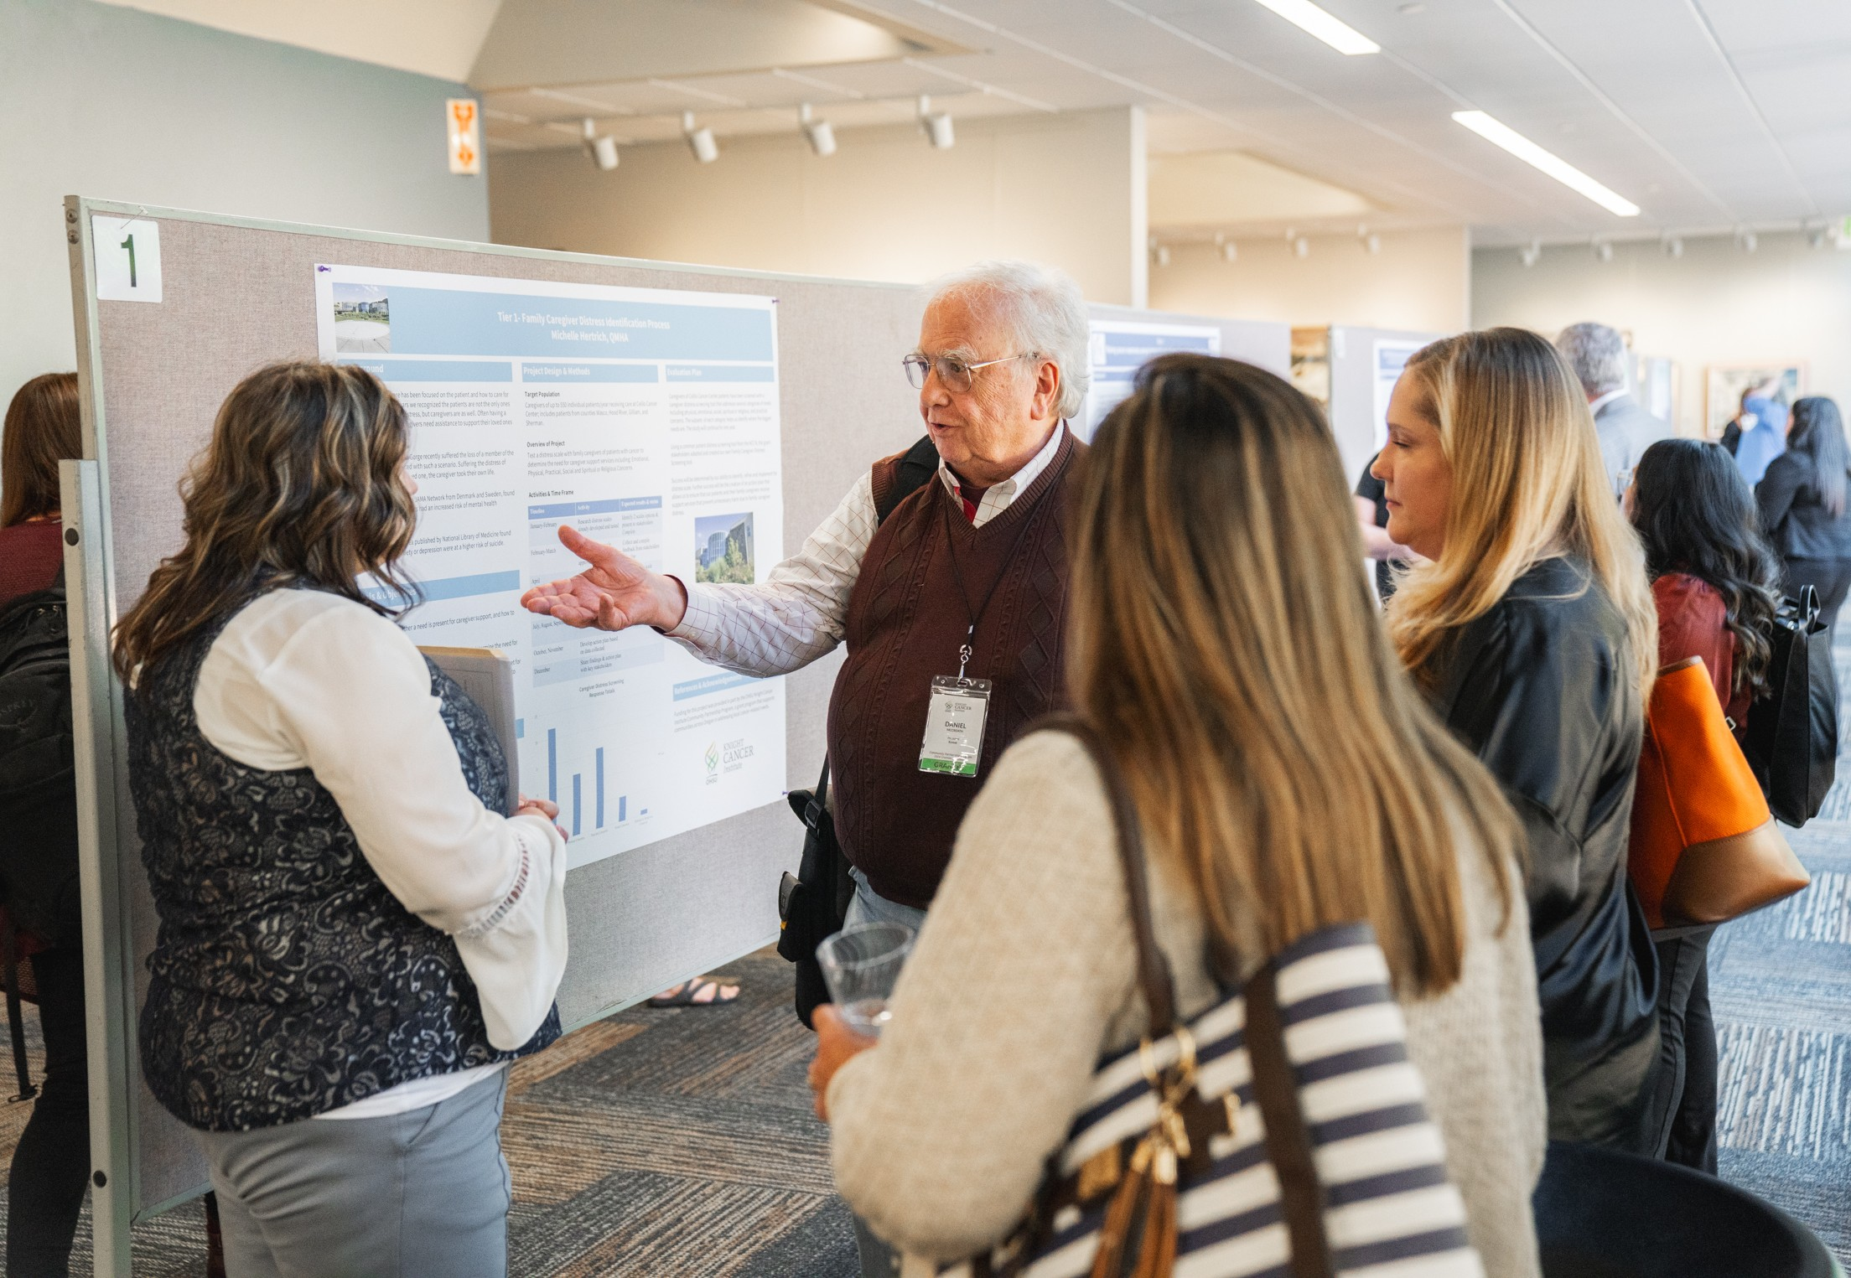
Target population(s)
If the proposed project targets individuals or groups from a specific population/community, specify below. If not, select Not applicable.
 | q | Age, seniors/elders (ages 65+)
 | q | Age, youth (ages 0-17)
 | q | Cancer patients/survivors
 | q | Caregivers
 | q | Immigrants and refugees
 | q | LGBTQ (lesbian, gay, bisexual, transgender, queer)
 | q | Persons with disabilities (impairment, activity limitation, participation restrictions)
 | q | Veterans
 | q | Not applicable
 | q | Other:

Appendix 3A Tier 1 proposal questions and review criteria
The following questions will be evaluated during the review process.
- Limit answers to a maximum of 250 words per numbered question/answer field unless otherwise specified.
- Both questions and answers will be provided to reviewers.

Project Description

Summarize your proposed Tier 1 project. This will be used as a summary of the full proposal at select points during the review process (450 words max.) Include:
  - What cancer-related topic and population do you want to learn more about and why? Include a brief summary of the “problem” and the proposal’s “goal” to address the problem.
  - In which geographic region will the project be focused?
  - Describe what strategy, method, or approach you will use to prioritize local cancer needs to create an action plan (needs assessment, coalition building)? If known, include the data collection methods you will use (not required).
  - What are the short and long-term goals of the project?

For example: In County, HPV immunization rates among Hispanic/Latino youth ages 11-17 are significantly lower in comparison to white youth. We aim to conduct a community needs assessment to understand the knowledge, perceptions and barriers of HPV immunization among
Hispanic/Latino residents in County. We will collaborate with the local health department to gain local data, conduct key informant interviews with parents ages 21+ and survey local Hispanic/Latino youth. The short-term goal is to identify priority topics for community education and to support our selection of an evidence-based approach for future implementation. Ultimately, we aim to develop a culturally appropriate approach for increasing local HPV immunization rates among Hispanic/Latino residents in County.

Significance and impact
Target population
Answers to narrative questions are limited to 250 words each unless otherwise specified.
- Describe the community or population(s) targeted by this project. Consider those both directly and indirectly affected by the selected cancer issue. Describe any current experience working with this community, if applicable.

Impact
- If successful, what potential benefit will this project bring to the target communities? How will this effort fill a gap in knowledge?

Approach
Methodology
- To best determine local cancer needs, describe the types of data you will collect and from which sources the data will come. See the How to Apply page of our website for guidance. Strong proposals should consider both types of the following data sources.
  - A secondary source provides information you can glean from an existing resource such as a website (such as Census.gov or State Cancer Profiles: statecancerprofiles.cancer.gov/) or a local county health department. Secondary sources are typically listed first because that is where your research will begin.
  - A primary source provides information you produce through engaging the community to learn more (surveys, focus groups, interviews, town hall meetings, etc.).

- Describe the process for using collected data to guide action plan development. Note: Tier 1 action plans will be submitted to CPP at the end of the grant period.

Outreach and engagement approach
- How will the target population(s) and/or key stakeholders described in question 2 be identified and engaged in this effort? Consider the community’s social and cultural preferences in your response.

Evaluation
- How will you determine success of this effort?

Sustainability
- Sharing what you learned is key to gaining community buy-in. Describe your plan for sharing results with others who can potentially contribute to or support the next phase of this effort. Consider how this project will help prepare your organization to apply for either a Tier 2 grant from the Community Partnership Program or to pursue other opportunities.

Project team
- Describe project team members (personnel, volunteers or other community members) and their roles on this project. If applicable, define any external partners (organization or individuals) and/or key stakeholders and their role on or contribution to this project. If the proposed project
is dependent on partner involvement, please demonstrate their commitment with letters of support.

Note: Applicants affiliated with an academic institution or university are required to partner with a community-based organization to ensure funds are invested into the target community. If you are affiliated with an academic institution or university, please also address the following:

  - Which community organization will you partner with?
  - What will the community organization’s primary role be?
    - Collaborative research
    - Financial
    - Formal relationship
    - In-kind (networking/information exchange)
    - In-kind (personnel)
    - In-kind (service/equipment)
    - Joint program sponsorship
  - Describe this partner’s proposed contribution to the project.

- What additional resources, if any, are available to support this project?

Supplemental documents for Tier 1
  - Upload budget and justification (use template provided on the How to Apply page of our website)
  - Upload letters of support from external partners listed in question 9 (recommended if project is a collaboration. Note: Do not include letters from organizations or individuals familiar with your work but will not be part of implementing the project. Participant and/or beneficiary testimonials are not to be included and will be deleted.)
  - Upload bibliography (optional)

Appendix 3B Tiers 2 and
3 proposal questions and review criteria
The following questions will be evaluated during the review process.
- Limit answers to a maximum of 250 words per numbered question/answer field unless otherwise specified.
- Both questions and answers will be provided to reviewers.

Project description
- Summarize your Tier 2 or 3 proposed project. While some projects may address multiple health issues in a population, funds are intended to specifically address cancer-related issues This summary should serve as a high-level overview of your proposal (450 words max.) This will be used as a summary of the full proposal at select points during the review process. Include:
  - What cancer-related need or issue are you aiming to address? Include a brief summary of the “problem” and the proposal’s “goal.”
  - In which geographic region will the project be focused?
  - If applicable, specify any cancer-related health disparities, including disparities related to race, ethnicity, socioeconomic status, gender identity, sexual orientation, geographic location and disability.
How will this effort aim to address these disparities?
  - Describe the strategy, method, or approach you will use to address the specific cancer- related issue. Clarify if it is a new approach, an existing evidence-based intervention, and/or a coalition driven activity.
  - What data collection methods will you use to determine success of this effort?
  - What are the short and long-term goals of the project, including sustainability plans?

- If this proposal aims to build upon a current or previously funded Community Partnership Program project, address the following (450 words max.):
  - Succinctly provide the aims and objectives of your most recent grant and describe if/how these objectives were met.
  - Include results from your project, such as process and/or outcomes data, and describe how this has built your capacity for progressing to the next phase of this project. If complete results are not yet available, provide preliminary or interim data.
  - Describe how this proposed project is separate from and builds upon your previous work.

Significance and impact
Local issue
- Describe the cancer-related need or concern this project addresses and explain the need for this project in your community. Describe any evidence that informed your decision to focus on this issue.
Answers to narrative questions are limited to 250 words each unless otherwise specified.

Evidence might include:
  - Published studies and reports of similar projects or programs demonstrating positive impact.
  - Collection of initial data (e.g. a community needs assessment).
  - Data describing a local gap or need justifying this project.

Target audience

Target population vs. target audience — example for a colorectal cancer screening project:

- Target population (who will be impacted by project activities): adults aged 50–75 in Blanks County.
- Target audiences (who will be engaged by project activities): Medicaid patients aged 50–75 who have not received colorectal cancer screening, plus providers and community health workers.

- Describe the target population affected by this issue, providing evidence to explain why this community was chosen for this project. Include how you plan to involve members from the target population in the project design.

- Describe any distinct target audiences (eight maximum) who will be engaged by the work of this project.

Impact
- How will this project support or advance existing or previous efforts towards addressing the identified cancer-related need in your community?

Approach
Grant tier
- Provide rationale for the grant tier chosen and why it is the best fit for this project.

- Upload a completed project objectives and timeline template found on the How to Apply page on our website, addressing the following (two pages maximum):
  - Three to five SMART objectives.
  - The key activities directly linked to each objective.
  - The anticipated outcomes for each objective (consider outcomes for your organization and for individual participants.)
  - Two to three measures for each outcome.
  - A timeline stating how and when key activities will be implemented and evaluated.

Methodology
- Describe the proposed activities per audience that will be used to achieve the stated goals and objectives (350 words max.) Include information on:
Use questions 9 and 10 to further describe the detail provided in your project objectives template.
  - Setting in which the project activities will occur.
  - Frequency of the proposed activities and/or how much of the intervention each target audience will receive to achieve stated outcomes (e.g. one weekly education
session for six months for providers, two trainings over 12 months for community health workers, etc.).
  - If proposing cancer screening, describe plans for connecting individuals who screen positive to resources for appropriate follow-up care.
  - If proposing a newly developed approach or activity, use data to justify how this is most appropriate due to limited existing efforts.
  - If implementing or adapting an evidence-based approach, briefly summarize the evidence supporting selection of this approach, why this approach is appropriate for your population and, if applicable, how it will be adapted to meet your community’s needs.

Evaluation
- How will you measure the impact or success of the activities described in your project objectives template (450 words max.)? Describe the evaluation plan, including:
  - How will you define success for your project?
  - What outcomes are you evaluating for (e.g. demonstrated feasibility, measured acceptability, increase in knowledge, increased understanding of local cancer-related needs, increased number of screenings, etc.)?
  - Describe your plan for collecting, storing and using the data referenced on your project objectives template. Explain your rationale for each.
  - Tier 3 only: Describe your plans for analyzing and reporting the data/findings.

Outreach and engagement approach
- What outreach strategies or tactics will be utilized to reach and engage the target audience(s)? How will you ensure the approach is socially and culturally appropriate for the community?

- What barriers do you anticipate in reaching the target audience(s) or implementing the project and how will they be addressed?

Sustainability or next steps
- What strategies do you intend to use to support future expansion or sustainability of this effort if successful? (E.g. Plans for securing additional funding, leadership/local buy-in, etc.)

- What are the biggest challenges to sustainability and how will these challenges be addressed?

Organization and team
Organization
- Describe your organization’s current goals and recent achievements. How will this project help you meet the existing mission and goals of your organization? If the project addresses a cancer- related health disparity, how is your organization uniquely qualified to reach the target population and implement the proposed project?

Partners/project team
- Describe project team members (personnel, volunteers or other community members), roles and their qualifications to successfully carry out this project. Examples include expertise, previous experience or related achievements, or existing resources that can be leveraged.

Note: Applicants affiliated with an academic institution or university are required to partner with a community-based organization to ensure funds are invested into the target community. If you are affiliated with an academic institution or university, please also address the following:
  - Which community organization will you partner with?
  - What will the community organization’s primary role be?
    - Collaborative research
    - Financial
    - Formal relationship
    - In-kind (networking/information exchange)
    - In-kind (personnel)
    - In-kind (service/equipment)
    - Joint program sponsorship
  - Describe this partner’s proposed contribution to the project.

- Define which community organization(s) and/or key stakeholder(s) you will partner with and describe each organization’s role or contribution to the project. If the proposed project is dependent on external partner involvement, please demonstrate their commitment with letters of support.

Supplemental documents for Tiers 2 and 3
  - Note: The objectives/timeline template is a required supplemental document but is uploaded as your response to question 8.
  - Upload budget and justification (required, using template provided on the How to Apply page of our website)
  - Upload letters of support from external partners listed in question 17 (at least one required; additional letters are optional but highly recommended. Note: Participant/ beneficiary testimonials or general letters of recommendation are not to be included and will be deleted.)
  - Upload bibliography/references (optional)

