**Accessible MS Word File Example with Errors (This should be Heading 1, or H1)**

1. Heading Styles
2. Tables
3. Hyperlinks
4. Alt text for images
5. Use Word’s built-in Check Accessibility. **Checker does not show:**
   1. No Repeat Header Row across pages
   2. Not using Heading Styles (H1, H2…)
   3. Full URL or “click here” as the link instead of descriptive link name

**Example of a Course Map with Heading Row Repeated Across Pages (Should be H2)**

There is a good chance that your table will repeat across pages. You need to make sure the table header row repeats across pages. Imagine if

See [**how to repeat header row across pages**](https://support.microsoft.com/en-us/office/repeat-table-header-on-subsequent-pages-2ff677e0-3150-464a-a283-fa52794b4b41).

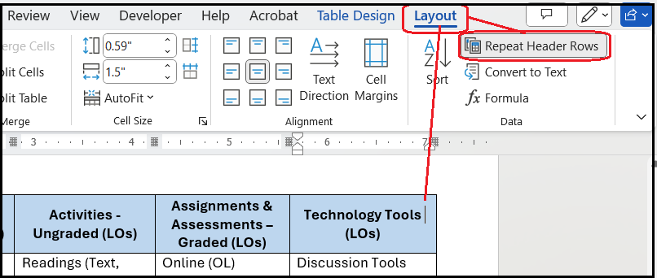

|  |  |  |  |  |
| --- | --- | --- | --- | --- |
| **Module or Week** | **Topics** | **Learning Objectives (COs)** | **Assignments & Assessments** | **Technology Tools (LOs)** |
| **1**  **Example** | Topic 1  Topic 2 | 1. LO 1 (CO 2, 3) 2. LO 2 (CO 1, 2) 3. LO 3 (CO 2) | Discussion (LO 3)  Activity 1 (LO 2, 3)  Assessment 1 (LO 1, 2, 3) | Discussion Tools (LO 1, 2)  Media Tools (LO 3)  Simulation Tools (LO 1, 2, 3) |
| **2**  **Course Example** | Accessing Evidence and Research | Conduct a search of the literature (CO 1)  Formulate a PICOT question (CO 1) | Explore OHSU Library resources for the School of Nursing website (LO 1, 2, 3)  Complete the PICOT Worksheet (LO 1, 2, 3) | OHSU Library database (LO 1)  Submissions tool in Sakai (LO 1, 2, 3) |
| **3** |  |  |  |  |
| **4** |  |  |  |  |
| **5** |  |  |  |  |

**Hyperlinks**

Use meaningful link text.

* **This:** [WCAG 2.2 Link Purpose (In Context)](https://www.w3.org/WAI/WCAG22/Understanding/link-purpose-in-context.html)
* **Not this:** [Click here](https://www.w3.org/WAI/WCAG22/Understanding/link-purpose-in-context.html)
* **Not this:** <https://www.w3.org/WAI/WCAG22/Understanding/link-purpose-in-context.html>

**Alt Text for Images**

Use List Styles



Here’s another example of an image that needs alt text.

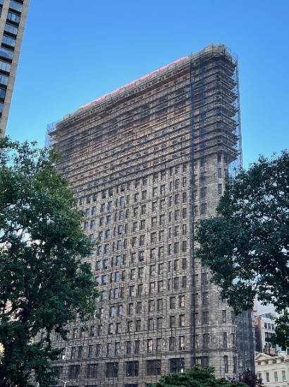

Here’s an image of text. The text should be the alt text



**Use the Built-in Accessibility Checker: Review > Check Accessibility**

Let’s check this one…